 | x1 | x2 | x3 | x4 | f
1 | 0 | 0 | 0 | 0 | 1
2 | 0 | 0 | 0 | 1 | 0
3 | 0 | 0 | 1 | 0 | 1
4 | 0 | 0 | 1 | 1 | 1
5 | 0 | 1 | 0 | 0 | 0
6 | 0 | 1 | 0 | 1 | 1
7 | 0 | 1 | 1 | 0 | 1
8 | 0 | 1 | 1 | 1 | 0
9 | 1 | 0 | 0 | 0 | 1
10 | 1 | 0 | 0 | 1 | 0
11 | 1 | 0 | 1 | 0 | 1
12 | 1 | 0 | 1 | 1 | 1
13 | 1 | 1 | 0 | 0 | 1
14 | 1 | 1 | 0 | 1 | 0
15 | 1 | 1 | 1 | 0 | 0
16 | 1 | 1 | 1 | 1 | 0

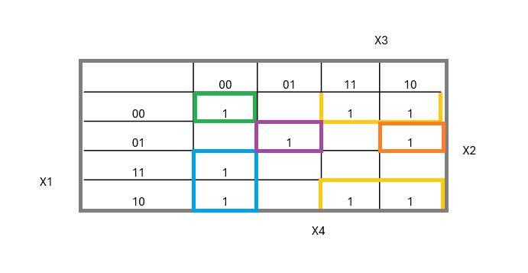
$$x_{1}⋅\overline{x_{3}}⋅\overline{x_{4}}∨\overline{x_{1}}⋅\overline{x_{2}}⋅\overline{x_{3}}⋅\overline{x_{4}}∨\overline{x_{1}}⋅\overline{x_{3}}∨\overline{x_{2}}⋅x_{3}∨\overline{x_{1}}⋅\overline{x_{4}}$$
